## **Triangle**

**Program Description:**

Create a program which will test whether three inputted sides will form a triangle. If a triangle is formed output the area, perimeter and type of triangle into label boxes. Adding extra

**Rubric:**

**“B”**

- area - perimeter - type of triangle, e.g., Right, Isosceles etc.

**“A”**

-graphics -calculated angles -animation

**Sample output:**

1. Gui before any input: 2. Gui if triangle doesn’t exist:

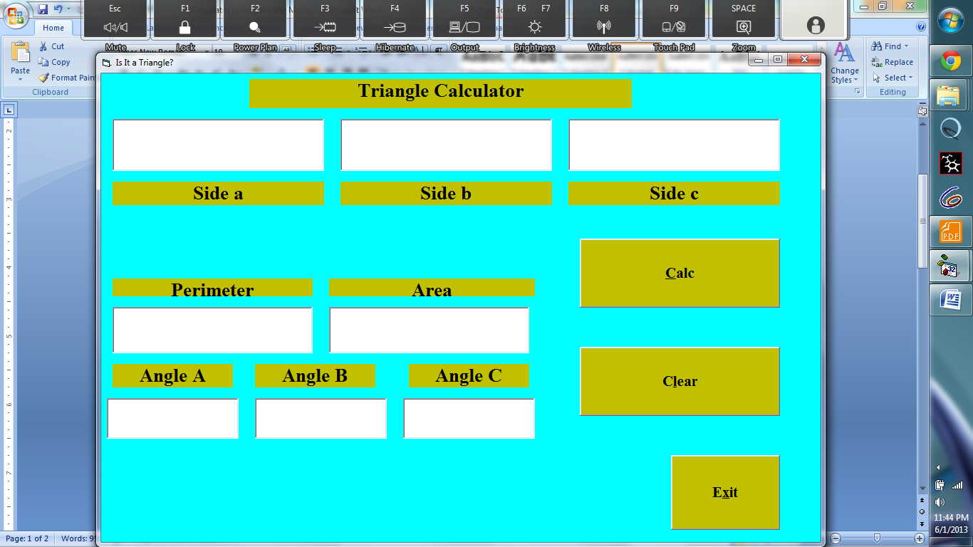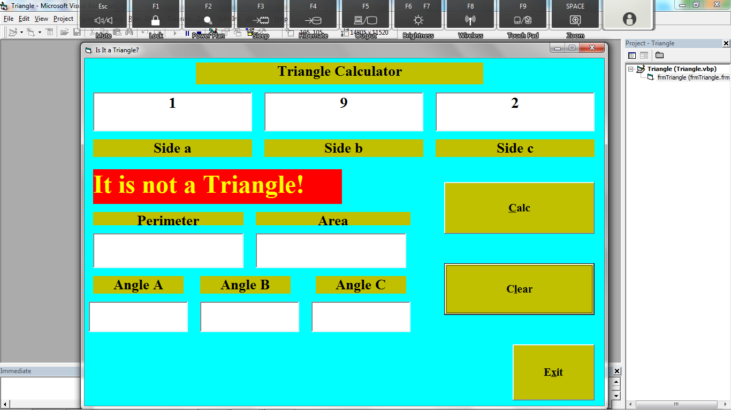

3. Gui if triangle exists:

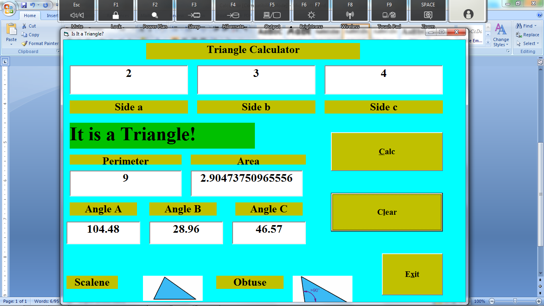

The clear button should bring the entire gui back to the state it was in before any input (figure 1).

Remember to tabstop the commands so that tabbing moves smoothly